BARN THEATRE

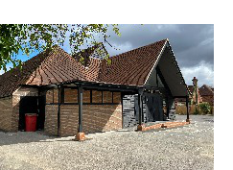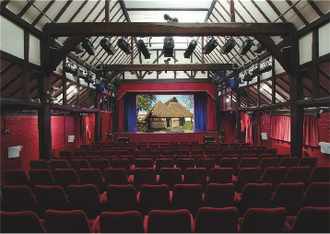

NEWS *Volume 30 Issue 1 February 2025*

I am proud to front the Really Happy Company. We are a group of friends, who, over the last decade have produced shows at the Barn aimed at financially benefiting both the theatre and charitable/community organisations, whilst enabling people to perform to the best of their ability. We hold great value for each other, as well as this building and this is what motivates us to continue producing such fun and creative shows. It is remarkable that in ten years, we have raised more than £95,000,

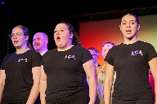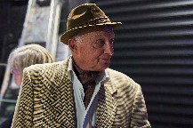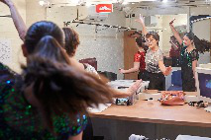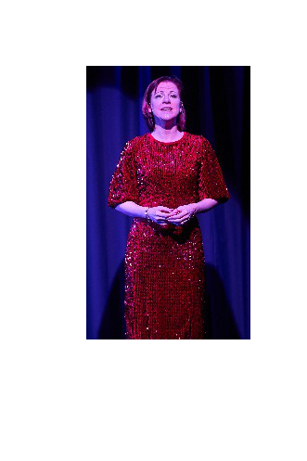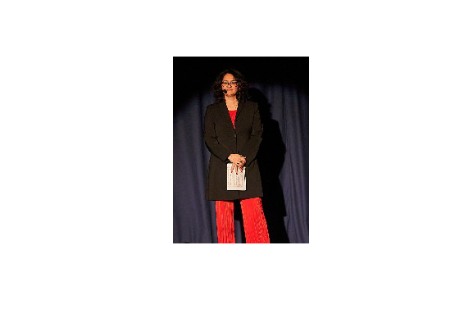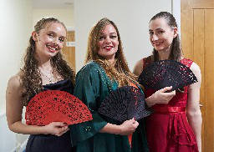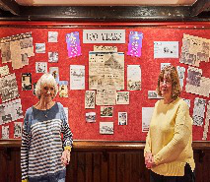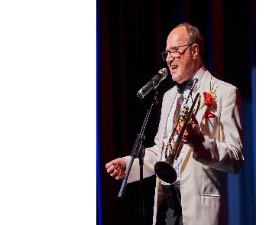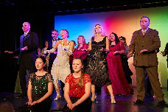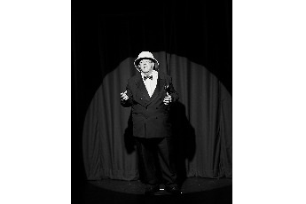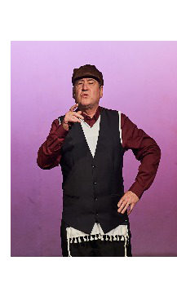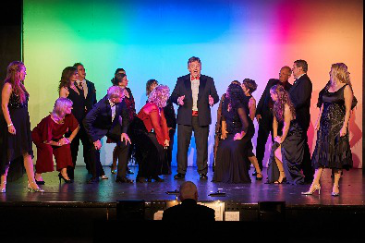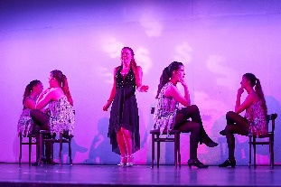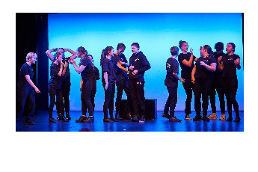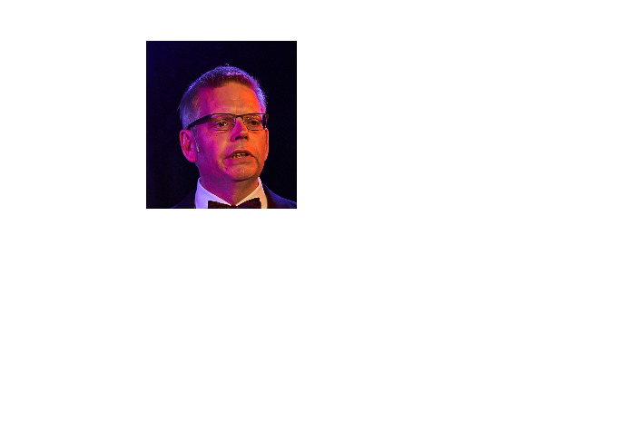

It was an enormous privilege to close the 2024 celebrations aimed at marking our wonderful theatre’s centenary birthday.

We were truly blessed to have Sarah Morrison directing this production, bringing a wealth of knowledge and her own unique talent to the stage. We were honoured to have a wealth of talent perform, who are well known to the theatre and I thank them all so much for their investment of time and energy over what was nearly a whole year from time of birth of this project to the 26th October!

Our Production Team consisted of the most experienced and fabulous individuals, again my thanks to every one of them for their time and energy to bring this show to the stage. The hours of work invested by countless individuals are too many to count but I feel I must give special thanks to Sue and Pete Marr for their input on all things administration and more thanks to Pete and Richard Grogan for the many hours spent compiling a simply fabulous projection of historical images, which were used during the show. Muriel Lister and Teresa Chinnock also worked tirelessly putting together a superb display in the foyer and bar areas.

A fabulous production and one that none of us will ever forget.





Step back in time to the glorious days of traditional Music Hall, presented by The Paper Moon Theatre Company and NFS productions on



. This spectacular production features performers who will delight and entertain you with great songs, dance, magic and laughter, all accompanied by the fabulous London Music Hall orchestra. This splendid production captures the true Victorian style of a much loved form of entertainment, it is colourful, superbly stagedandcostumedandfullofaudienceparticipation. A nostalgic, fun and unmissable trip down memory lane from this galaxy ofstars from BBCTV’S “The Good Old Days “

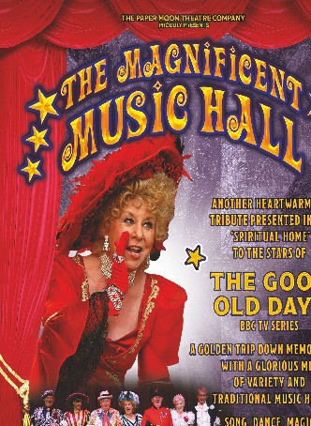

Carefree, Cheerful and Uniquely British.

“This is cutting edge Victoriana - beloved by the British and their visitors” TIME OUT.

Join us for an enchanting journey into the world of fairytales, where you and your little ones can sing, dance and dream, enjoying well-known classic songs.

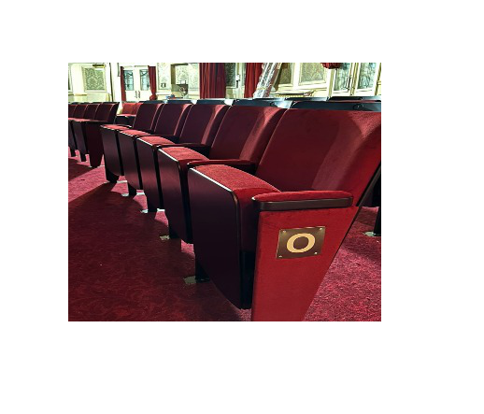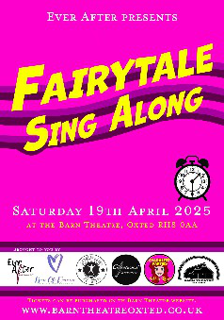

The magical sing-along features a selection of timeless fairytale songs split over two chapters, from letting go and we don't talk about Bruno.

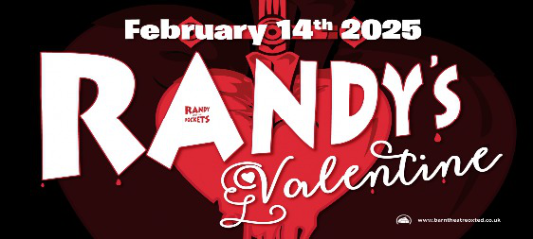With dance performances from KPA Dance and beautiful vocals from some of our local singers of all ages. Don't miss 2025's Fairytale Sing Along.

**● ●**

**●**

**● ●**

New seating and carpets ordered

The present seating was installed in 1991 and has done us very well but despite continuous repair and replacement of parts, we now consider the structure of some seats not to be as good as it should be. The illustration on the right is one of the seats we have considered, together with a change to red carpeting to match the bar. Deposits of over £50,000 have been placed to secure the seating and carpeting in time for the installation, starting in late August. More later but you will be able to sponsor the new seats if you wish.

This year’s FOBS Annual General Meeting will be held on the evening of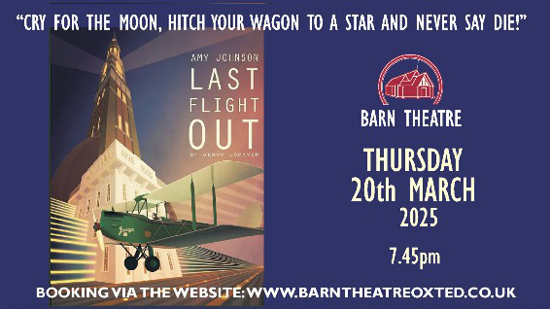

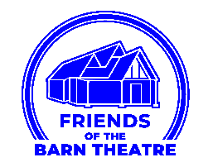

Do please come along to hear what we achieved in 2024 and to air your views. The meeting is open to anyone who wishes to attend and official notification will be sent to everyone on our membership list within the next fortnight. If you are interested in joining our committee, please contact me at the following email address to find out more: fobs.chairman@barntheatreoxted.co.uk

We have been delighted to welcome a number of new volunteers recently, but are always on the lookout for more. So if you are able to give even a small amount of time to helping with front of house duties, we would love to hear from you. I’d like to say an enormous thank you to the 40 volunteers who between them filled the 110 duties that were needed for the TOPS panto last month - always our busiest time of year. It was an amazing effort and the rota was filled several weeks in advance of the first performance, which makes Nikki’s job so much easier. Thank you too, to those who stood in at the last minute when illness prevented a small number from being able to carry out their duties.

This year’s calendar is looking as busy as ever, so do please respond to Nikki with whatever offers of help you can give. It truly is deeply appreciated.

Paul Robinson – Chairman of FOBs

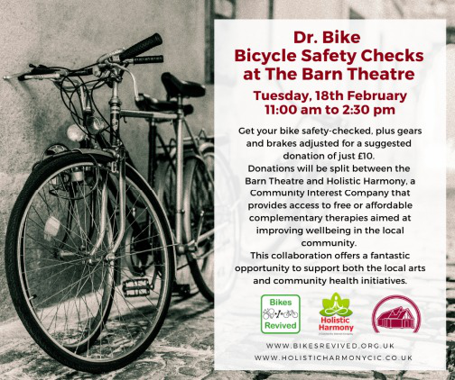Book now www.barntheatreoxted.co.uk

With a classic five-piece line-up of long-time members, fronted by founder-member Rod Clements on vocals, mandolin, fiddle and slide guitar. With a repertoire of unforgettable songs like , , and , and a reputation for live performance second-to-none, Lindisfarne’s power to galvanize festival and concert audiences remains undimmed and is guaranteed to get the crowd on their feet and singing along.

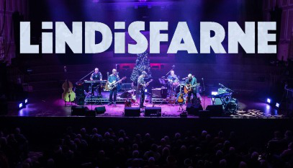

In 2024 the band headlined iconic London venues Shepherd’s Bush Empire and Cadogan Hall – both holding around 1,000 people – so to see them in the far more intimate surroundings of the Barn is a rare treat indeed!

LINDISFARNE 2025 are:

ROD CLEMENTS (1969-present) Vocal, mandolin, fiddle, guitars DAVE HULL-DENHOLM (1994-present) Vocal, guitars

STEVE DAGGETT (1986-present) Vocal, keyboards, guitars IAN THOMSON (1995-present) Bass, vocal

PAUL SMITH Drums

Lindisfarne emerged from Tyneside in the 1970s and quickly carved out a unique place for themselves as one of British rock’s most original bands. Their pioneering sound,

combining acoustic instruments like mandolin and fiddle with their electric blues roots, proved the perfect medium to deliver the catchy, memorable songs provided by the band’s resident writers Alan Hull and Rod Clements.

Their first hit, the Clements-penned , paved the way for their classic to become the UK’s top-selling album of 1972.

The original band finally called it a day in 2003, but now Lindisfarne are back with a classic five-piece line up of long-time members fronted by original founder-member Rod Clements (vocals, mandolin, fiddle, slide guitar) and Alan Hull’s son-in-law Dave Hull-Denholm (vocals, guitars).

**Film making Presentation at the Barn**

I work for Waythrough, a charity supporting those challenged by emotional unwellness and mental health conditions. Becky, our Co-Production and Engagement Officer, asked participants at our Enrich Forum what sort of courses and activities they would like to see.

Knowing that filmmaking is one of Becky’s passions, the group suggested they would like to try filmmaking themselves! Starting in August, Becky hosted an exciting seven-week programme that explored all aspects of the craft of filmmaking. The final, eighth session culminated in a special screening at our very own Barn Theatre

Nothing more than a smartphone was required!

Six completed films were shown at the finale and in lieu of adverts, stunning still-life photographs taken by one of our volunteers were projected onto the screen while people took their seats and during the interval.

Following the interval, we were delighted with a performance by the Include Choir, https://include.org/the-include-choir/ and everyone was treated to popcorn! The entire Waythrough Community Connections team helped—from car park duties to ushering and vacuuming stray popcorn afterwards!

The short films were individually spectacular, covering a wide range of topics and styles, but all were equally poignant and thought-provoking. We were particularly impressed by Nick, who hadn’t even known how to take a video on his phone before the course but submitted a moving film about nature and mental health.

Feedback from the filmmakers was that they found the whole experience incredibly absorbing, making it a fantastic diversion from their mental health struggles.

Examples of the films, the choirs and the lovely ushers keeping us all in order

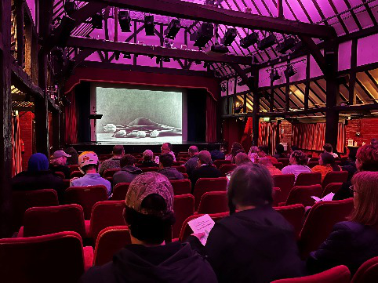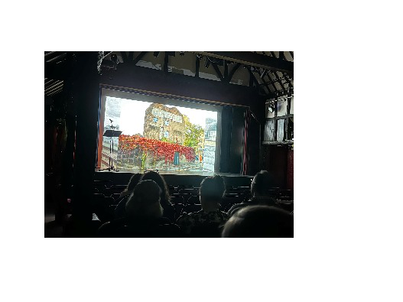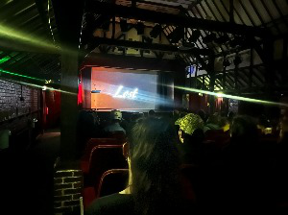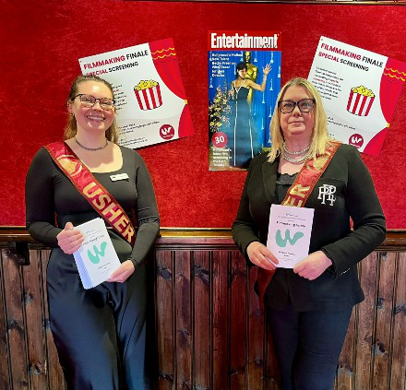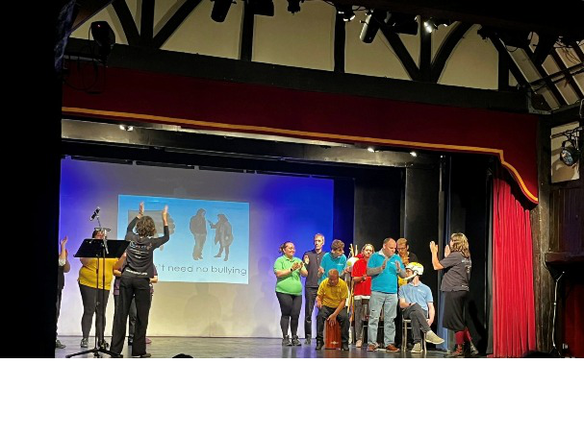

The Barn Theatre News is created by Bruce Reed who is always willingtoreceiveyourcontributionatbarntheatre@btinternet.com Copy for the next edition should be received by Friday 18th April