NAME A SEAT

PLEASE USE A SEPARATE FORM FOR EACH
SEAT PLAQUE REQUIRED

YOU CAN CHOOSE A SEAT NUMBER IF IT IS STILL AVAILABLE.
EACH SEAT NAME COSTS £100 AND INCLUDES A BRASS PLAQUE AFFIXED TO THE REAR FRAME OF THE SEAT

YOUR NAME, EMAIL ADDRESS AND PHONE NUMBER

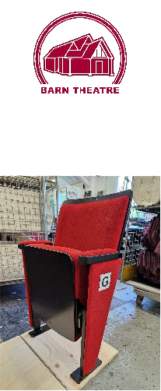
YOUR CHOICE OF SEAT NUMBER

YOUR PROPOSED PLAQUE WORDING
30 CHARACTERS MAXIMUM

Payment, which should be made at the same time as submitting the form, to be made by bank transfer to Oxted and Limpsfield Barn Theatre account 75687569 60-16-09 quoting seat number(s) as a reference or by cheque sent to Barn Theatre Office, 15a High Street, Westerham, Kent. TN16 1RA. DO NOT SEND TO THE THEATRE

