Welcome to the Barn Theatre monthly e-Newsletter

 | 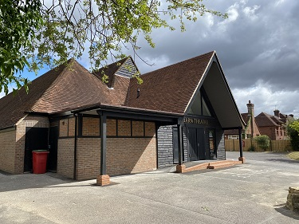
  Barn Theatre
  September eNewsletter

www.barntheatreoxted.co.uk

Hello All

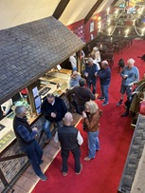
SUNDAY CLUB
After a very successful Sunday Club last month, we are holding the next Sunday Club on 6th September
Sunday Club is held in the bar at the theatre on the first Sunday of every month from noon until 2.00pm, when the bar is open and nibbles are served. If you are new to the theatre, why not come along to find out more about what happens there, or if you are an 'old hand', come to meet friends or network. We all work very hard, so this is a chance to relax and enjoy somewhere that means so much, to so many.
Do come and join us, even if it is only for a quick hello, we would love to see you!

AFTER MUCH DISCUSSION WE HAVE DETERMINED THAT THE BARN THEATRE SITE WILL BECOME TOTALLY NO SMOKING (OR VAPING) FROM 1ST FEBRUARY 2026. PLEASE RESPECT OUR DECISION.

David Burchardt, who is masterminding The UK Theatre Tour has done a video of the theatre which has been posted to YouTube https://youtu.be/maHD2u8b1Hs. In the years to come, he hopes to visit every theatre in the UK and we are lucky to have been one of the first. He is looking for suggestions as to which theatre to visit next and things are made easier for him if the theatre actively makes contact with him, so please do contact him via his Instagram account @theuktheatretour if you would like him to visit your theatre.

Our next events will be Flash - A Tribute to Queen on 11th September, Oxted Comedy with Paul Sinha on 12th September, Musicals in Their Eyes on 13th September, The Ultimate Elvis Experience on 19th September, Oxted Sessions with Andy Fairweather Low and the Low Riders on 24th September and Classic Rock Revival on 26th September

As usual, we will keep you updated via the eNews and will post our events on our website, and our Facebook page

Many people have asked to receive our information only by e-mail, so to ensure you don't miss out on anything, here is a link to the Barn Theatre News. Don't worry, if you have elected to receive snail-mail information, you will continue to do so.

We have been testing an online donation tool called easyfundraising who partner with over 7,000 brands who will donate part of what you spend to the Barn. It won't cost you any extra as the cost is covered by the brand. It is very easy to install & use on any device, so please follow this link and select us as your chosen charity. https://www.easyfundraising.org.uk/create-an-account/

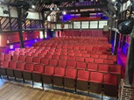
ON TIME, IN BUDGET AND LOOKING FANTASTIC!
THE NEW SEATS AND AUDITORIUM CARPETING.

NAME A SEAT
For a donation of £100, you can pick a seat and have an engraved plaque personalised with your choice of up to 30 characters. Your plaque will remain in place for the life of the seat.
You will be able to visit your seat for a photo opportunity at any time you are in the theatre.
Please do help by either buying a seat from Ticketsource or electronically complete a form from here or on the website and email to barntheatre@btinternet.com or pick one up from around the theatre and return to the Barn Theatre Office, 15a High Street, Westerham, Kent, TN16 1RA
Payment details are on the form
This is obviously a very expensive project so please do buy a seat if you can.

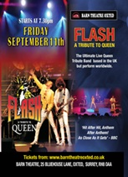
Our story is set in the wild west lands of Deadwood City, Dakota Territory 1876. The atmosphere in this rustic backwater is lusty, warm and completely dependent on the safe arrival of the stagecoach for supplies and communication.
Here we follow the adventures of outspoken and fearless Calamity Jane who dresses, rides and shoots like a man, but given the chance shows she can be a beautiful girl who yearns for the love of a man.
Will this man be dashing Lt. Danny Gilmartin or the justly notorious Wild Bill Hickock? The hilarious twists and turns of the plot lead the audience to a most unexpected outcome.
This well-loved musical is being performed by Kenley Holiday Workshop and has toe-tapping melodies and tells the story of bravery, friendship, love and finding where you truly belong.
Performances are 12th – 15th August at 7.30pm and tickets costing £18.00 are available from www.barntheatreoxted.co.uk

__________________________________________________________________________________

The Barn Theatre relies entirely on the support of volunteers and wishes to provide a safe and welcoming environment for all our visitors. To this end we are looking for volunteers who hold a current First Aid Certificate issued by a recognised body, to join a team of First Aiders covering our events and shows. This certificate should cover primary and secondary survey techniques and the holder must be proficient in performing CPR and the use of a defibrillator. Although on duty individually, back-up support will generally be available.
If you feel able to help us in this role which comes with a free ticket to the event, please either respond to this email or John Kempton on jskempton@tiscali.co.uk

We are also booking tickets for:
- Steel Magnolias by Robert Harling by The Oxted Players (13th - 17th October)
- All Shook Up by Oxted Musical Theatre Company (3rd – 7th – November)
- Not The Rolling Stones (13th December)
- House of Stand-Up with Hal Cruttenden (30th January)

 |  | 
Join over 2000 supporters  on our Facebook page to  find out everything that is  going on | Support the theatre by  buying  Tandridge Together Lottery  tickets and have the chance  of winning £25,000 | Tweet with us and follow  our hashtag #BarnOxted  Tweet with us and follow

Hope to see you at the next Sunday Club, or as soon as possible in the future and that you will support us as much as you are able.

Cheers

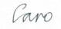
E-mail: publicity@barntheatreoxted.co.uk
Website: www.barntheatreoxted.co.uk
Phone: 01959 561811
Charity No: 1064318

You are being sent this eNews because you are a member of a society who performs at the Barn, in which case we have decided you have a genuine and legitimate interest in the theatre, or you have requested to go on the database, either verbally or by purchasing tickets via Ticketsource and ticking the box which allows Ticketsource to share your data with ourselves. If you wish to unsubscribe please e-mail publicity@barntheatreoxted.co.uk

